Go to Reports and go to Account Health

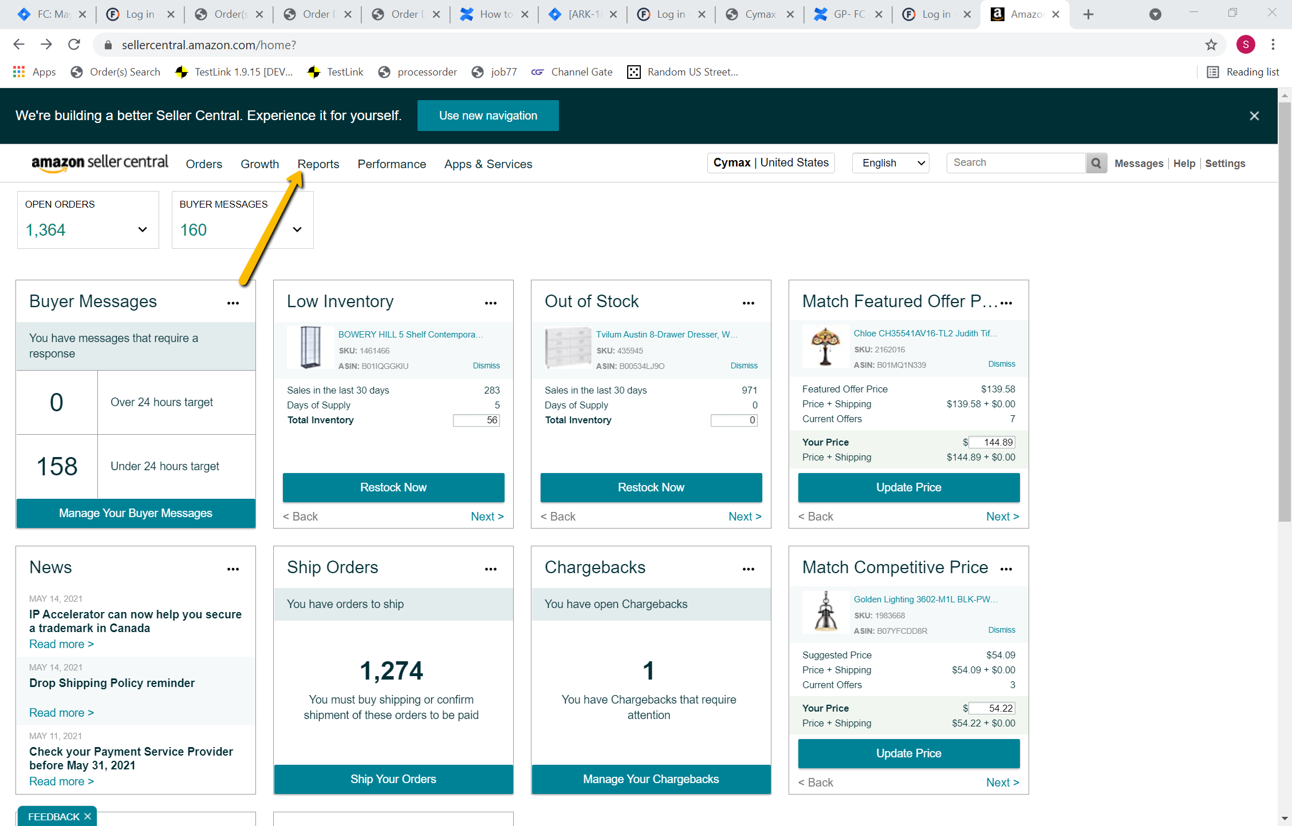

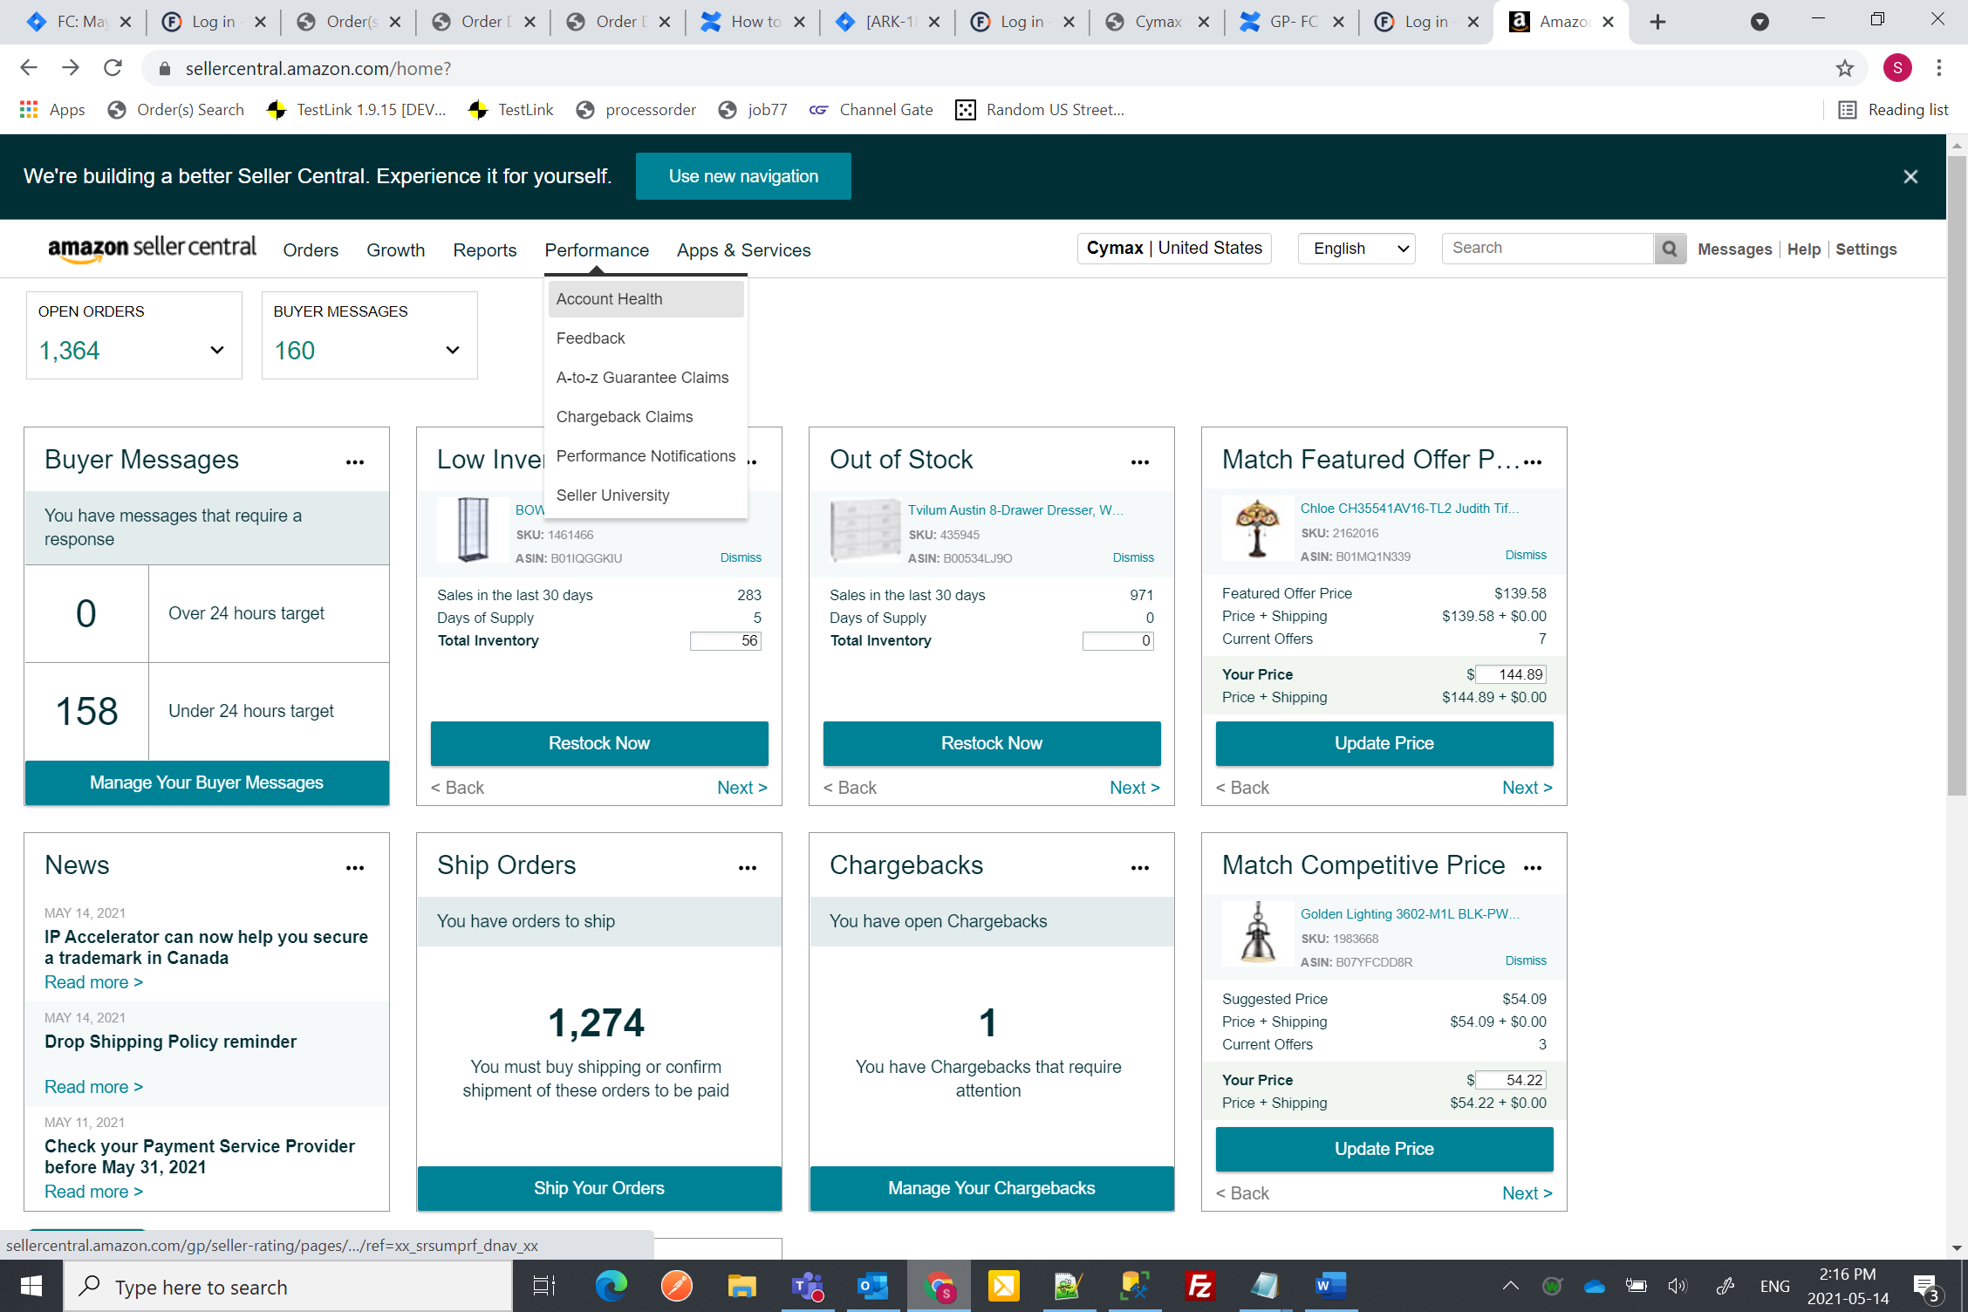

Go to Reports and click on Orders with defects

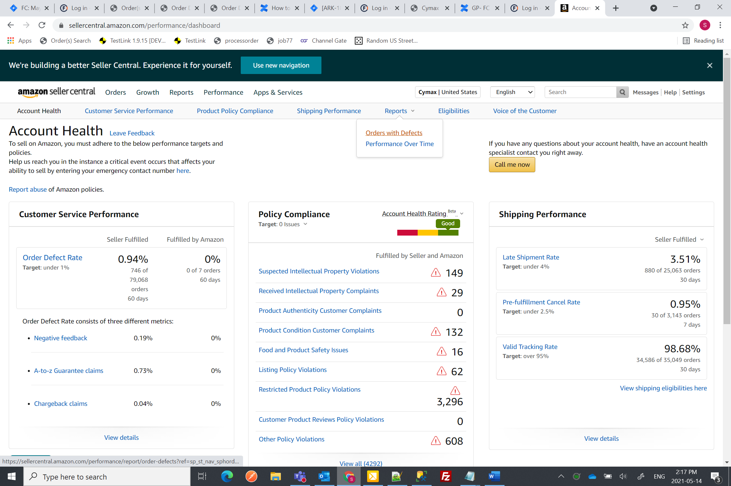

Click on the Graphs, Use the formula (<<Today Date>> - 15 Days)-60 days, Suppose today is 14th May then we go 15 days back which is April 30th and 60 days back which is March 01, So we need to take in account Bars from Month of March and April. On May 27th we go 15 days back, it will be 12th and then 60 days back. It will 12th March, then we need to consider Bars from March, April and May

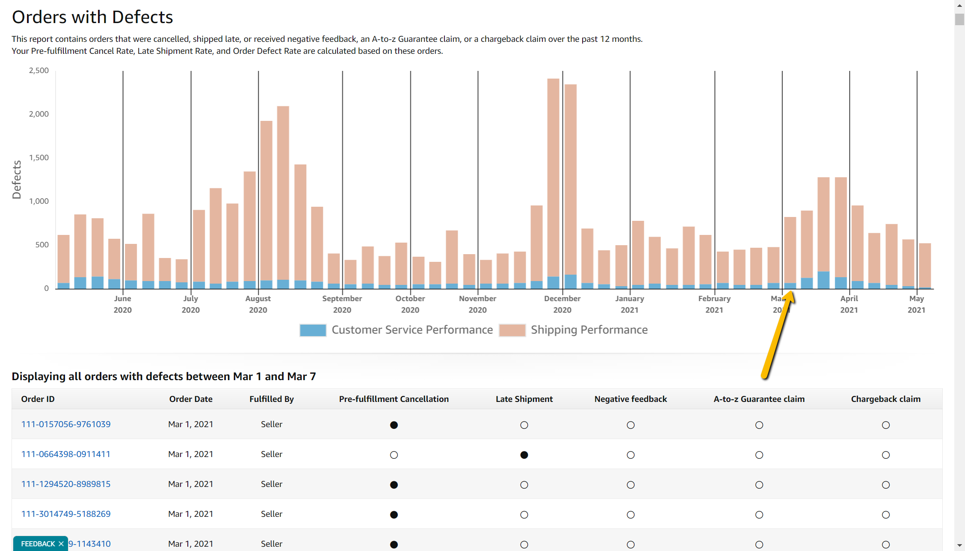

From below table, we need data Order Id, Order Date, Fullfilled by and Last three columns (If the Dot is Black) i.e. Negative Feedback, a-to-z Guarantee Claim and Chargeback Claim.

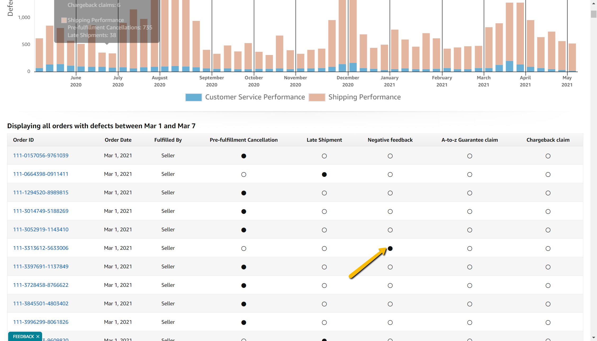

Expected Out Put should similar to below table in Excel sheet:

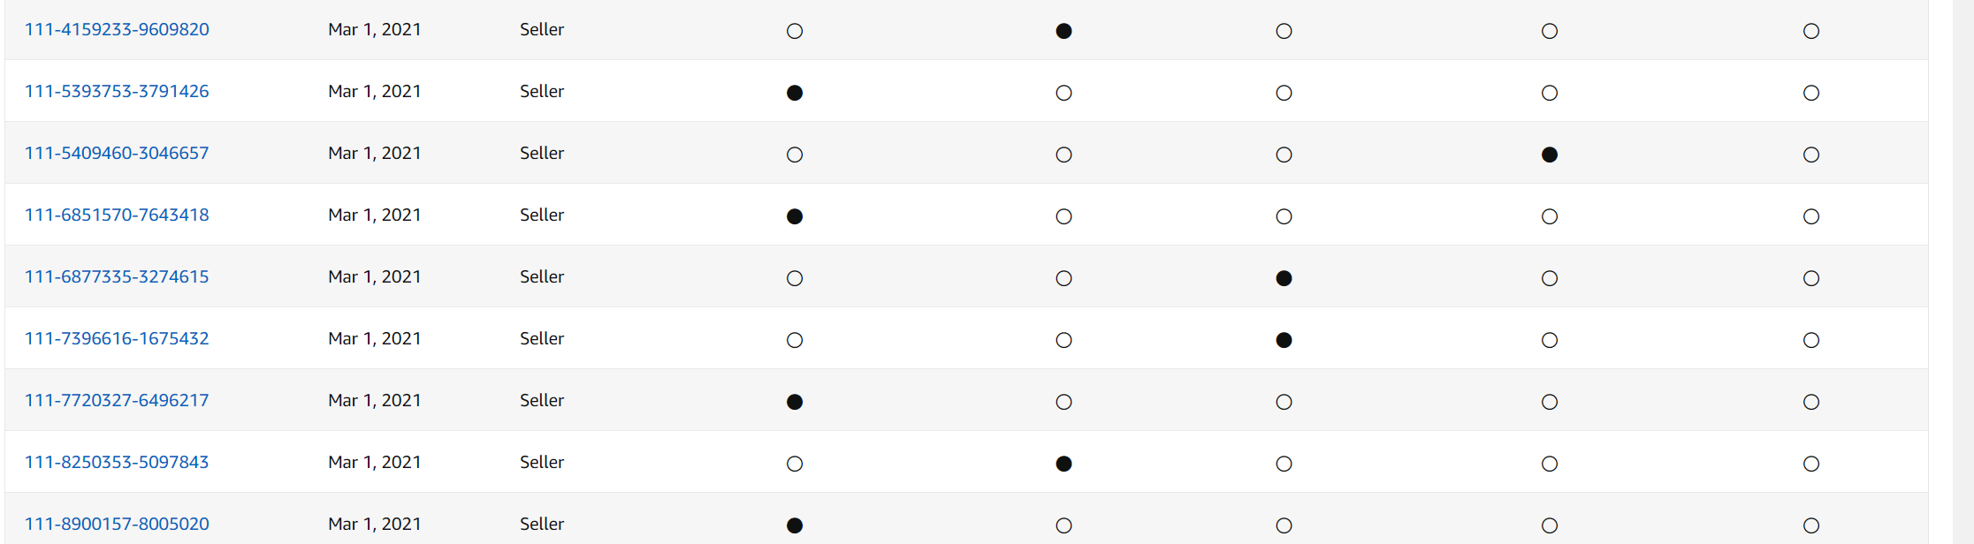

Excel output for above Screenshot would be:

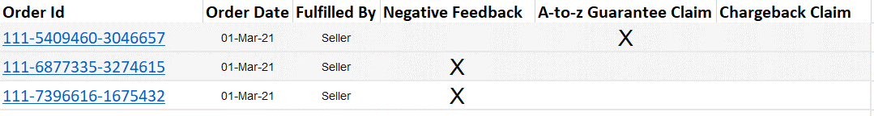

Naming Convention for the Excel file: <<DATE>>_Order-with-defects

Location: FTP location, URL will be provided later